

**Predictive Analytics**

***Algorithmic Trading– Stock Market Prediction***

***By,***

***Deni Avinash Aalla Balaji***

***Aaqil Rahman***

***Rohit Ramna***

**Section 1: Introduction**

A stock is the capital raised by a business or corporation through the issue and subscription of shares. The stock market is made up of exchanges. Stocks are listed on a specific exchange, which brings buyers and sellers together and acts as a market for the shares of those stocks.

Algorithmic trading also called as automated trading, uses a computer program that follows a defined set of instructions (an algorithm) to place a trade. We will use suitable time series algorithms to predict the stocks.

**Section 2: Problem Statement/ Research Question**

Stock market analysis is divided into two parts – Fundamental Analysis and Technical Analysis.

* Fundamental Analysis involves analyzing the company’s future profitability based on its current business environment and financial performance.
* Technical Analysis, on the other hand, includes reading the charts and using statistical figures to identify the trends in the stock market.

Being the most valuable companies in the world, Our aim is to do a comparative study of Apple and Microsoft’s stocks and learn how our predictive analytics models work.

***Sub Section 2.1: Importance***

A systematic trader cannot stand the degree of uncertainty by relying on studying the charts manually and reading the signals. He/she prefers to make predictions based on historical data, build an algorithm strategy that suits the market conditions, code it and turn it on. This project can be used by investors to take right decisions and can be used a tool by traders.

**Section 3: Data**

* **Data Source:** [**https://www.quandl.com/**](https://www.quandl.com/)
* **Snapshot of the data set**

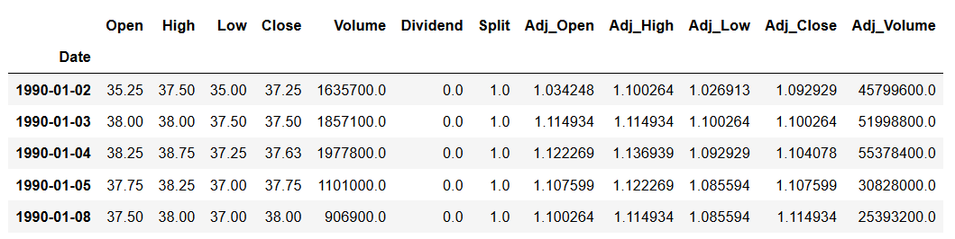

* **Data Description**

**Date:** It represents the date value, it doesn’t include Saturdays, Sundays and public holidays.

**Open:** It represents the price at which the stock opened that the corresponding date.

**High:** It represents the highest price of the stock on the corresponding date.

**Low:** It represents the lowest price of the stock on the corresponding date.

**Close:** It represents the price at which the stock closed on the corresponding date.

**Volume:** It represents the trading volume of the stock. It is commonly reported as the number of shares that were traded that day.

**Dividend:** It is the distribution of reward from a portion of the company’s earning and it is paid to a class of its shareholders.

**Split:** A stock split is a corporate action that is usually done by companies to make their share price more marketable. It doesn’t affect a company’s total market capitalization, but it does affect the company’s stock price.

**Adj_Open:** It stands for adjusted open price. An adjusted open price is a stock’s opening price on any given day of trading that has been amended to include any distributions and corporate actions that occurred at any time before the next day’s open.

**Adj_High:** It stand for adjusted high price. An adjusted high price is a stock’s high price on any given day of trading that has been amended to include any distributions and corporate actions that occurred at any time before the next day’s open.

**Adj_Low:** It stand for adjusted low price. An adjusted low price is a stock’s low price on any given day of trading that has been amended to include any distributions and corporate actions that occurred at any time before the next day’s open.

**Adj_Close:** It stand for adjusted close price. An adjusted close price is a stock’s close price on any given day of trading that has been amended to include any distributions and corporate actions that occurred at any time before the next day’s open.

**Adj_Volume:** It stand for adjusted volume. An adjusted volume is a stock’s traded volume on any given day of trading that has been amended to include any distributions and corporate actions that occurred at any time before the next day’s open.

***Sub Section 3.1: Data Preprocessing***

The data is complete, there is no missing values or inconsistency in data.

* Data Reduction: As our aim is to predict the future Close stock price of Apple and Microsoft, We reduced our dataset to Date and Adj_Close.

**Section 4: Methodology**

Following methodologies were chosen:

* **Moving Average**
* Assumptions and constraints: We used only the Adj_Close to predict stocks using moving average.
* **LSTM – Neural Network**
* Assumptions and constraints: We made X variable as current date’s Adj_Close and Y variable as Next day’s Adj_Close.
* **Auto Regression**
* We first found if the Lag plots are linear or not to confirm the usage of Auto Regression.
* We used Date and Adj_Close for Auto Regression.
* **Auto Arima**
* We used Date and Adj_Close and Seasonality in the model as ‘False’ as there is no seasonality pattern in stocks.
* **Programming Language**: Python

**Section 5: Results**

Following are the results for AAPL and MSFT stocks:

**Moving Average:**

Valid vs Predicted: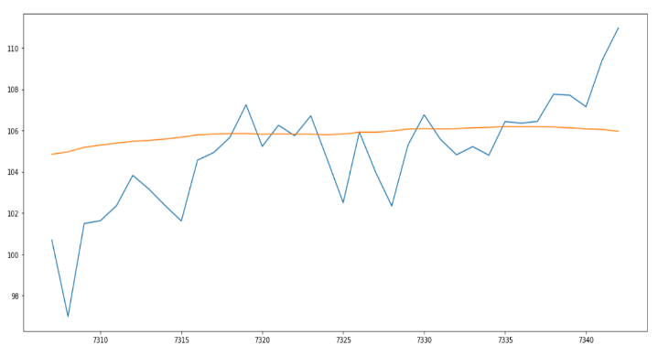

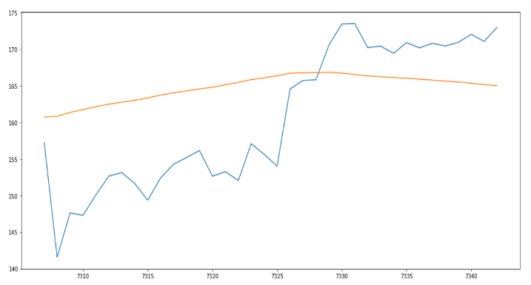

Prediction of Next 7 Days:

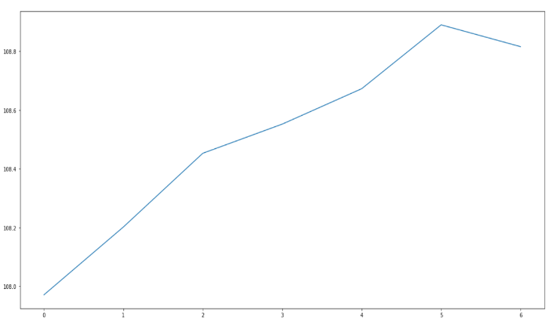

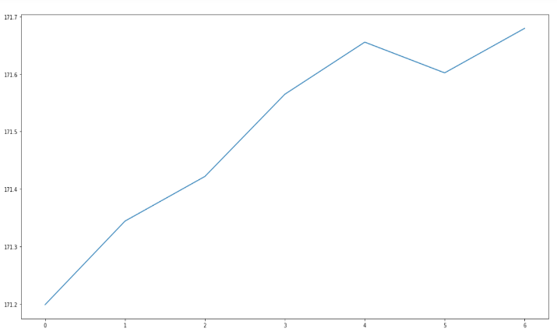

**LSTM – Neural Network:**

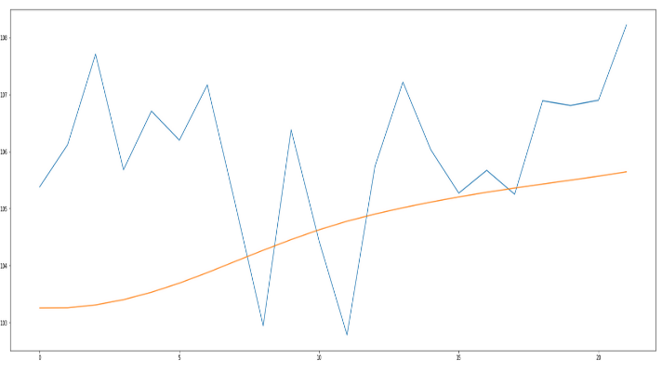Valid vs Predicted:

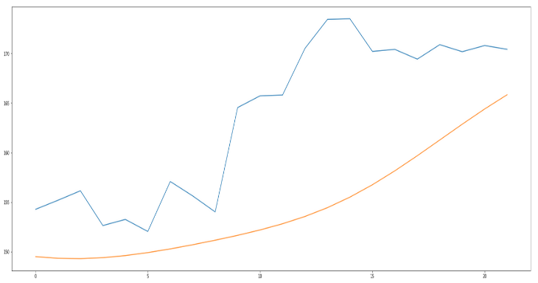

**Auto Regression:**

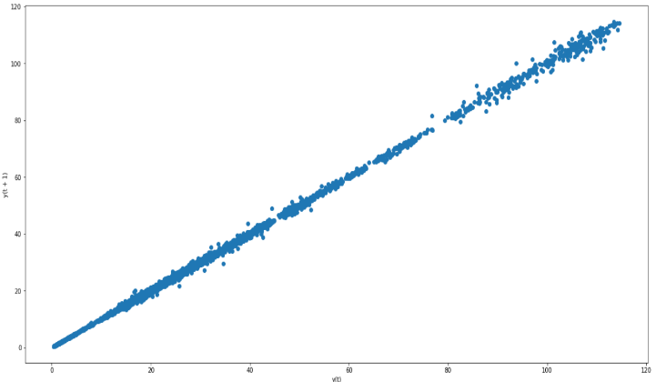Precondition – Lag Plots

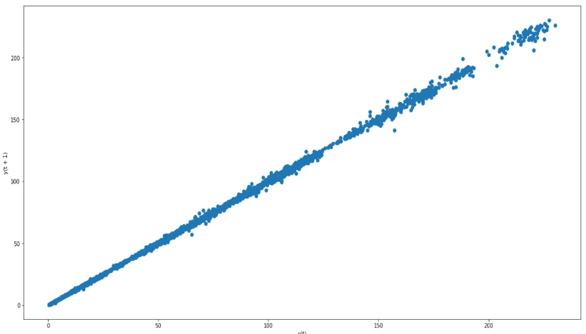

Valid vs Predicted

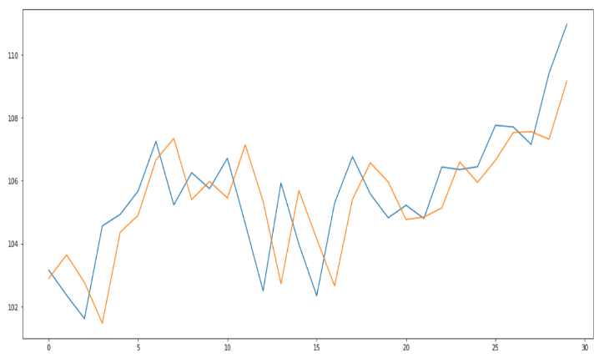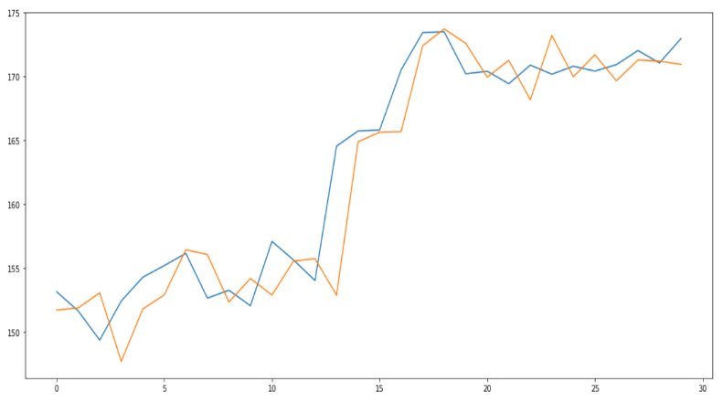

Predicted Values for next day:

AAPL : 170.878411

MSFT : 107.379865

**Auto Arima**

Valid vs Predicted

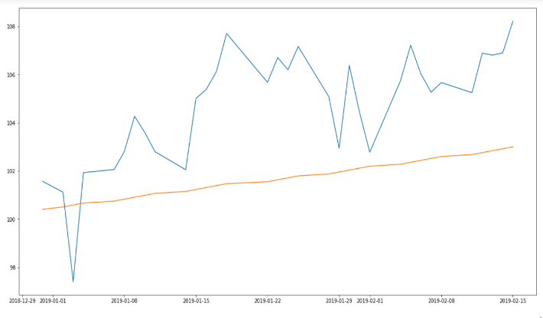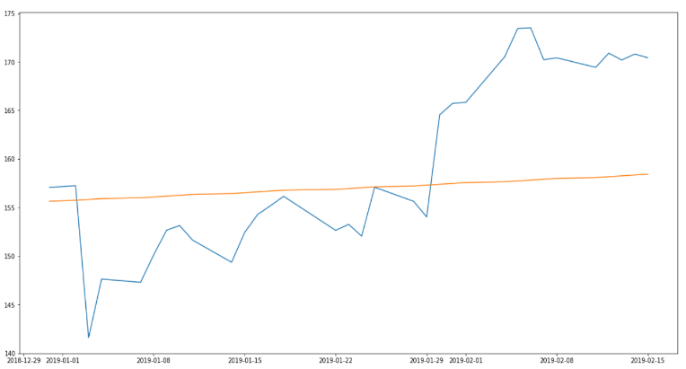

Predictions for next 5 days:

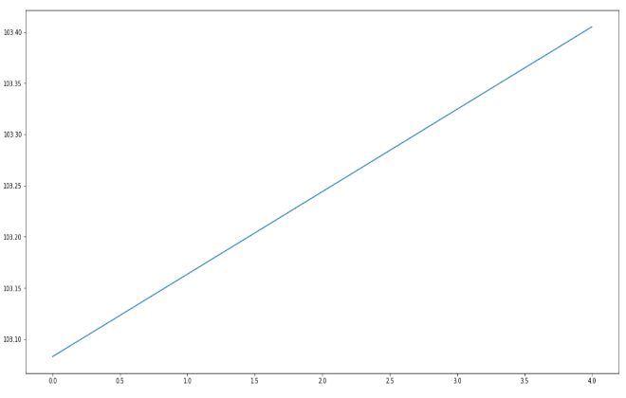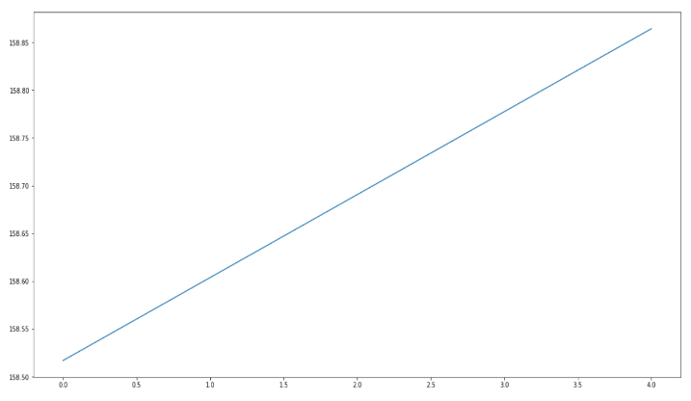

**Performance Results:**

**AAPL:**

|  |  |  |  |  |
| --- | --- | --- | --- | --- |
| **Metrics** | **Moving Average** | **LSTM** | **Auto Regression** | **Auto Arima** |
| **RMSE** | 9.2 | 10.2 | 8.6 | 9.4 |

**MSFT:**

|  |  |  |  |  |
| --- | --- | --- | --- | --- |
| **Metrics** | **Moving Average** | **LSTM** | **Auto Regression** | **Auto Arima** |
| **RMSE** | 2.5 | 2.1 | 3.5 | 2.4 |

***Sub Section 5.1: Discussion of Results***

* From the graphs and RMSE results, We can say that Apple is an inconsistent company in stock market with sudden peaks and drops, while Microsoft is a steady company with smooth growth.
* From our work, we can say that Auto Arima works very well for the companies that are inconsistent in stock values and the other options(specially LSTM) works better for consistent trends.
* While investing on stocks, we have to make sure that we invest on the right time knowing the trends of Inconsistent companies like Apple.
* We neither lose nor gain big when we invest on steady companies like Microsoft.
* The above models can be used as a tool to boost predictions.

***Sub Section 5.2 : Limitations:***

We are predicting Stocks only based on the past data, predicting the future with high precision is still a tough ask. Fundamental Analysis based on Business environment and current affairs play a vital role in stock movements. We did not capture that in our current work.

***Sub Section 5.3 : Future Work:***

Sentiment Analysis Approach:

* Pick up the New York Times and skim over the business section. As you read, you form opinions about the character and prospects of the myriad companies featured in the daily news. Your brain arrives at a “sentiment” score based on a rubric of positive, negative, or neutral emotions stimulated by the text.
* We can integrate our existing Predictive algorithms with Sentiment analysis for better

predictions in reality.

**Section 6: References**

* <https://marketsmith.investors.com/stock-charts/how-to-read-stock-charts/>
* <https://www.nerdwallet.com/blog/investing/stock-market-basics-everything-beginner-investors-know/>
* <https://www.researchgate.net/publication/327967988_Predicting_Stock_Prices_Using_LSTM>
* <https://www.sas.upenn.edu/~fdiebold/Teaching104/Ch14_slides.pdf>
* <https://www.investopedia.com/articles/active-trading/052014/how-use-moving-average-buy-stocks.asp>
* <https://www.digitalocean.com/community/tutorials/a-guide-to-time-series-forecasting-with-arima-in-python-3>